Software Screens for Packaging Supplies

Cost Estimating / FARM OUTS

Just one letter automates the distribution logic in the estimating program. Must distributors of packaging also buy and manufacture packaging materials such as boxes, folding cartons, foam, displays and partitions. Advantzware handles the manufacturing or buy/sell fast and easy. Many box plants that resell packaging supplies do not want the end user to know that they are buying the product. The best way to hide this fact is to create a quote with the same specifications as a converting plant. The Advantzware P/M for purchased / manufacturer field automatically sets the estimate as a BUY/ SELL order. This includes a FARM folder that houses unlimited vendor costs for the product. The P field also sets the costs equal to zero for glue, ink and imports a farmout machine to the rounting with zero cost. This allows the sales representative, customer service department or estimator to enter all the needed specifications such as box size, board grade, colors, untization details and any other manufacturing requirements. This data can then be printed on the quote and will also be transferred to the box plants purchase order so that the vendor will produce the item to the correct specifications.

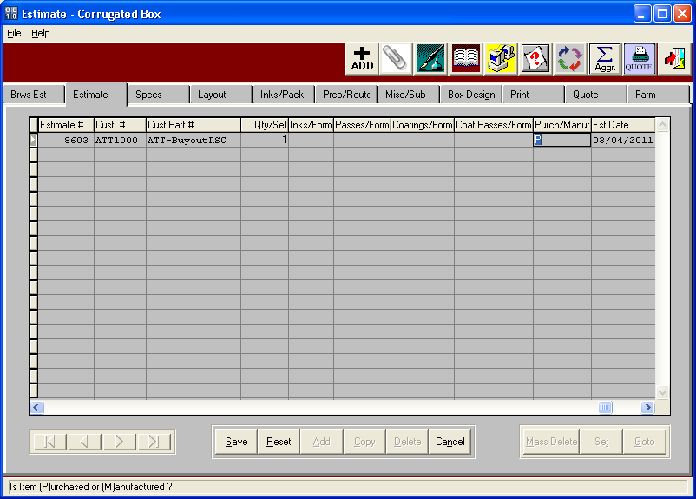

Cost Estimating / FARM OUTS

Vendor costs are easily stored for purchased boxes, die cuts, foam, folding cartons, point of purchase displays or assembled partitions. The FARM folder allows defining the quoted cost for each requested quote quantity. The program also tracks the setup charges by quantity and the minimum and maximum sheet sizes that each vendor can manufacture. The programs picks the best cost for each quote quantity for transfer to the quote history file. Once an order is placed for this customer part, the Advantzware order entry program will create a sequentially numbered finished goods item code and transfer the estimates FARM folder costs to the box plant inventory item, which will transfer to the purchase order to the vendor. Depending on system setup parameters, the system will check reorder levels and prompt to create the vendor purchase order during the order entry process.

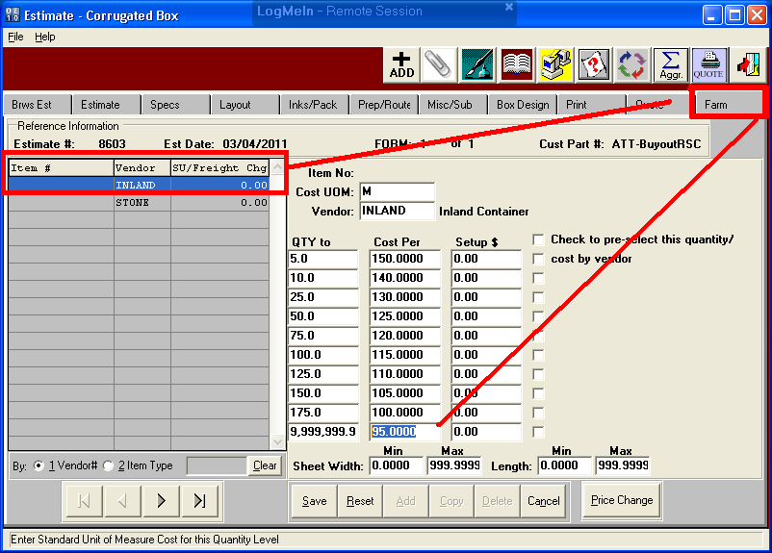

CUSTOMER QUOTES

The PRINT folder calculates each quantities sell price based on the best cost from each vendors cost matrix. The WHATIF button allows the sales manager to change gross profits, net profits or margins to determine the sell price. Of course, changing the sell price to match a competitor will recalculate margins,commissions and profit percentages. Once the sales price is set, this information is transferred to quote history for future analysis.

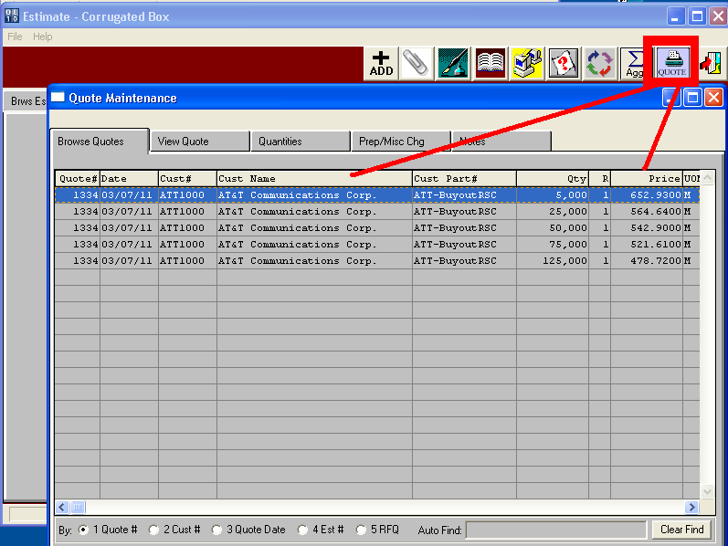

CUSTOMER QUOTES

The quote file houses the data to print or email the quote from complete with you company logo. The email will be sent directly to contract names defined on a distribution list for this customers, simply by clicking the QUOTE and email buttons.

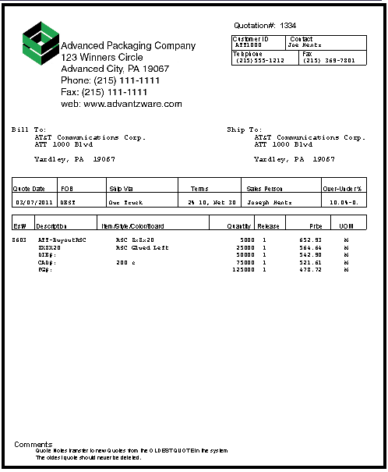
CUSTOMER PRICE SHEET

The quote history file can also produce a price list of purchased items. The plus sign allows adding a quote from the customers part history. The box plant can select brom the entire list of manufactured and purchased items sold to the customer. This price sheet created provides the customer a reorder sheet.

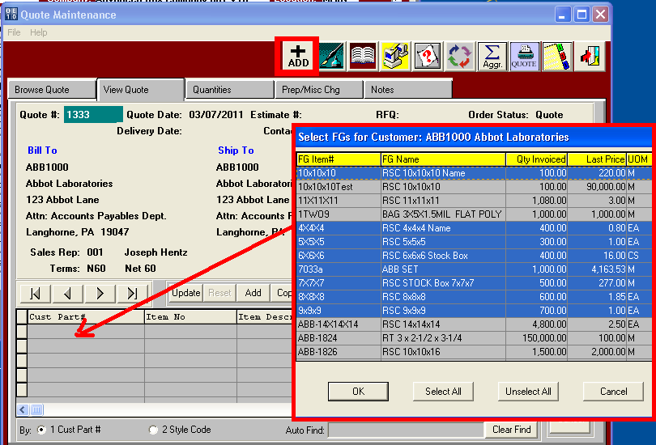

CUSTOMER PRICE SHEET

Only the items selected will print on the customer price sheet. This is a good business form to email to the customer so they know what items they buy from your company and what the on hand balance for each item. The price sheet provides the customer a reorder sheet so they can simply enter an order quantity and fax or email back to your sales department.

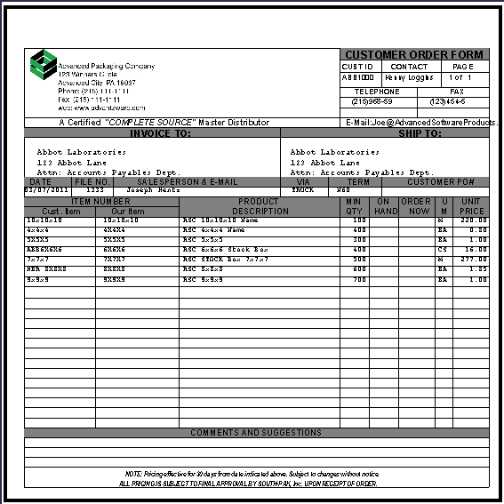

Order PROCESSING - ORDER Entry

This screen shows the power of Advantzware’s ability to combine a variety of finished goods types. Orders may be downloaed electronically via web orders from your website attached to ASI ANYWARE or manually typed by customer service. Orders for custom jobs, farm out items and packaging supplies can be added to a single customer order. This saves data entry time as one order, on order acknowledge and even one bill of lading can be created from this single order. The program is smart enough to create a job for custom boxes and to prompt to create purchase orders for purchased items such as farm outs and packaging supplies. Customer service types an estimate number for custom jobs or farmouts or leaves this field blank to search for a packaging goods stock items. Customer service presses the “+” Sign or “Add” button to add a customer order then bypasses the estimate number to add orders for packaging goods and stock items.

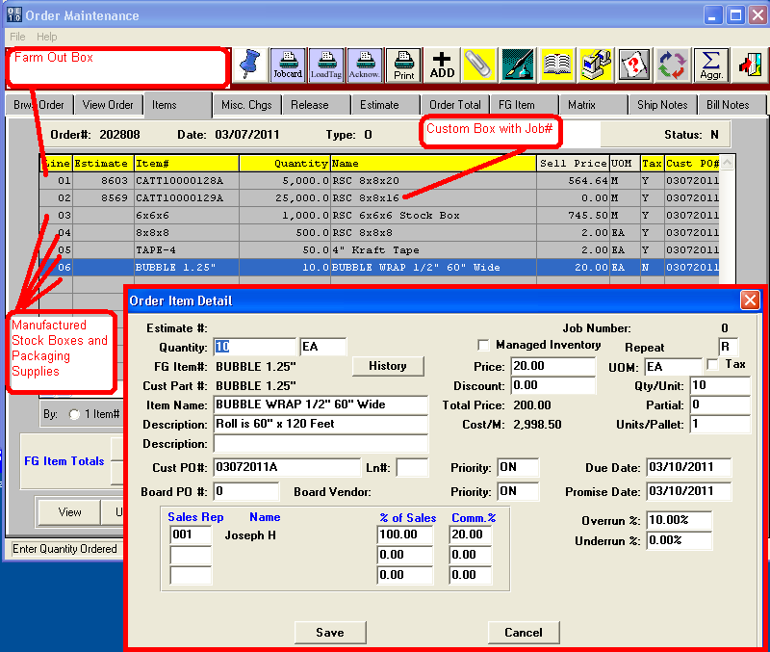

Order PROCESSING - PRICE MATRIX for CUSTOMER PRICING

The Price Matrix houses unique prices for each finished goods item. This example shows unique pricing for an 8x8x8 for customers IBM, ATT and ABC which have sell prices per Each. This screen also shows that all customer defined as a customer type equal to brokers will have unique pricing per thousand starting at $1,050 per thoushand for the smallest quantity. The price matrix listed with no customer and no customer type will be used for all other customers including counter sales and walk in customers. The detail price matrix for customer ATT1000 can house 10 unique selling prices for each quantity break. Alternatively, the matrix can be set to provide a discount off list price from the inventory file.

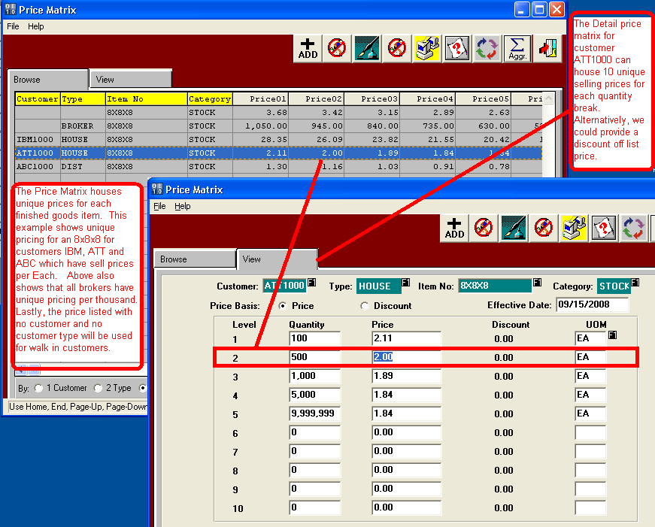

Order PROCESSING - ADDING ITEMS FROM SALES HISTORY

Another unique feature of order entry is to choose an item from past sales. The HISTORY button shows all the previous sales to the customer on the order. Double click on any item will show the previous invoiced price. If the customer service selects this item, the price and item will transfer to the order entry screen. Click, click, click and the order value is increased which the your on the phone with the customer.

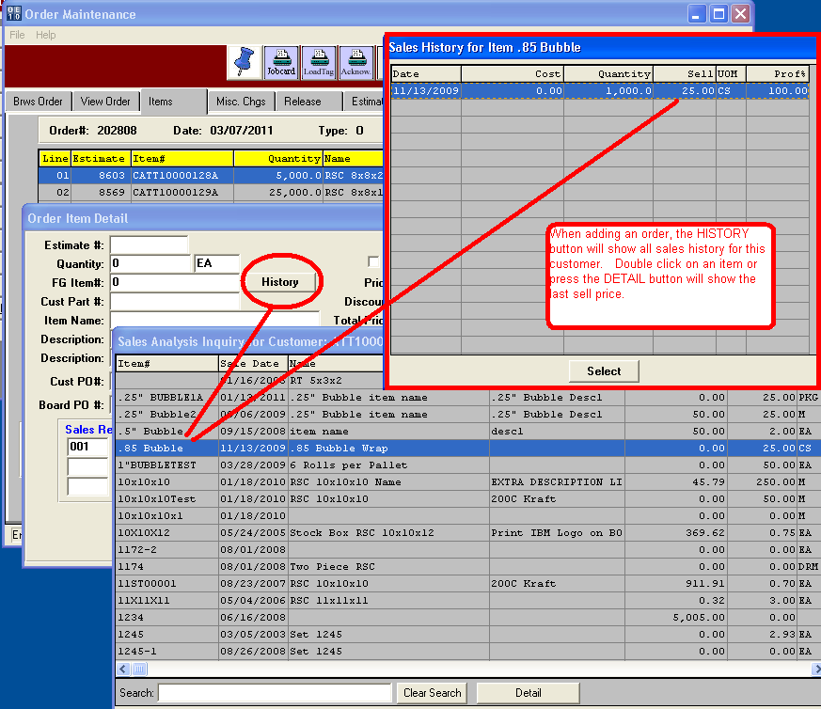
Order PROCESSING - ADDING ORDERs fop PURCHSED CUSTOM BOXES

The estimate 8603 is for a purchased farm out box so the program knows to prompt to create a purchase order for the finished goods item. Please note, the program automatically creates a very well orgainized item code complete with the item master record with all manufacturing specs and inventory on order and allocated quantites updated.
The system displays the best cost vendor to place purchase order and also asks if this is a drop shipment so your vendor can deliver directly to your customer. Advantzware also saves many hours processing drop shipments while keeping tight inventory control.

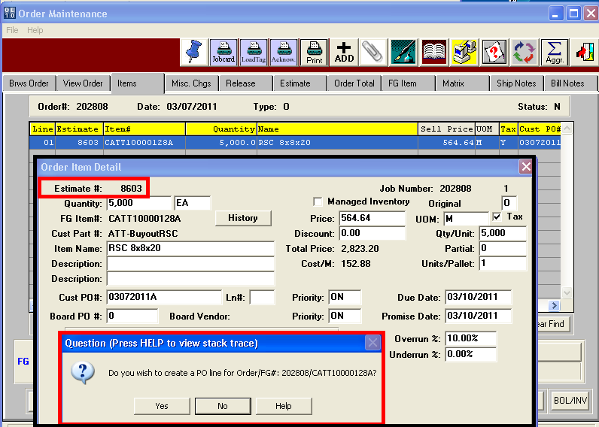

Order PROCESSING - ADDING ORDER & JOBS fop CUSTOM BOXES

The estimate 8569 is for a manufactured custom boxes so the program knows to prompt to create a job to produce the item but also creates a purchase order for the raw material board material. The program creates a very well orgainized item code consisting of the product category code – C for customer box, the customer code ATT1000, a sequential part number specific to this customer and a revision code letter A. Advantzware sets the item master record with all manufacturing specs such as die number, plate number, colors, blank size and vendor costs. In addition, the inventory balances such as job quantity on order and customer allocated quantites are updated.

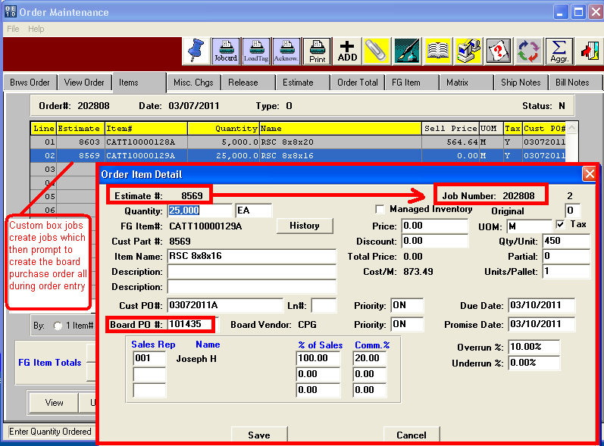

Order PROCESSING - Release / Delivery dates

The Advantzware order entry software serves as a blanket ordering system that allows unlimited deliveres for any or all items on the order. Each delivery may have a unique ship location, ship quantity, delivery date, shipping instructions and a unique customer purchase order code. This saves countless hours keeping all the deliveries on a single customer order versus creating a separate order for each delivery. Normally, shiping automatically creates the invoice based on the quantity delivered on the bill of lading. However, the release process allows shipping goods on consignment without invoicing, known as ship only releases. Alternatively, an item may be warehoused for a customer for a contracted period of months. Once that time expires, the release status changes to an “I”nvoice status prompting for billing. However, if the customer has limited warehouse space, we can create an invoice only delivery without shipping the goods. Advantzware will provide inventory reports for customer owned inventory that has not shipped. Please note, the quantity allocated can be set to update only once a customer has confirmed a delivery date. In this example, the customer ordered 25,000 boxes and has requested five separate deliveries, however only one has be releases.
This tight inventory control will prevent placing orders to replenish inventory as the available quantity is only updated from actual allocated.

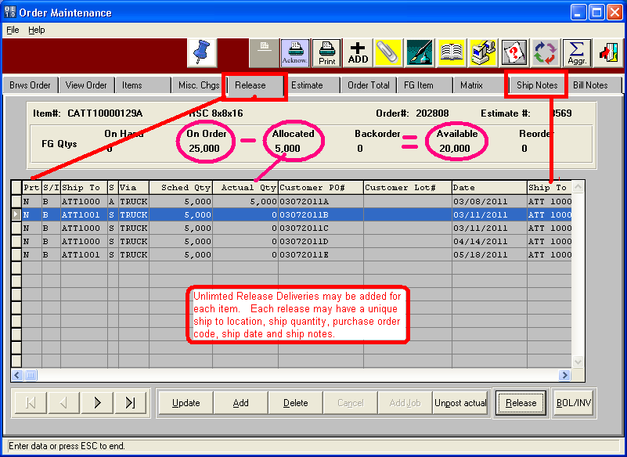

inventory receipts for drop shipments

Orders for packaging supplies and purchased custom boxes may be shipped directly to the customer. Most vendors have the ability to ship the goods with the box plants bill of lading and logo. Drop shipments save time and money by saving delivery costs and materials handling charges. However, inventory control must still be mainained by the box plant. Advantzware has a drop shipment feature that processes the inventory receipt, release, shipment and invoice all in once step. Once the vendor notifies you that the finished goods have been shipped to your customer, a simply receipt is all that is needed.

